Article 17 — The Automation Layer
Michal Doroszewski

The Conveyor Belt That Won’t Stop
You’re in a distribution warehouse. A conveyor belt hums along, carrying packages toward a sorting machine. A worker scans a box. The machine flashes: “Processing…” then shoves it down the wrong chute. Another box arrives. The machine hesitates, then pushes it into a bin marked “Recheck.” A third box arrives. The machine does nothing. The belt keeps moving. The box falls to the floor.
The worker hits the stop button. Nothing happens.
He hits it again. The belt speeds up.
He hits “Manual Override.” The screen says: “Automation in progress.”
Packages pile up. Boxes fall. Alarms chirp. The system continues making decisions no one asked it to make, based on signals no one trusts, using logic no one can see.
The conveyor belt isn’t broken. It’s automated — without truth, without context, without stability.
That is the Automation Problem — not the “bad script” kind, but the architectural kind. The kind that appears when cloud systems automate decisions based on incomplete signals, inconsistent evaluations, and contradictory trust states. The kind that turns a helpful conveyor belt into a runaway machine.
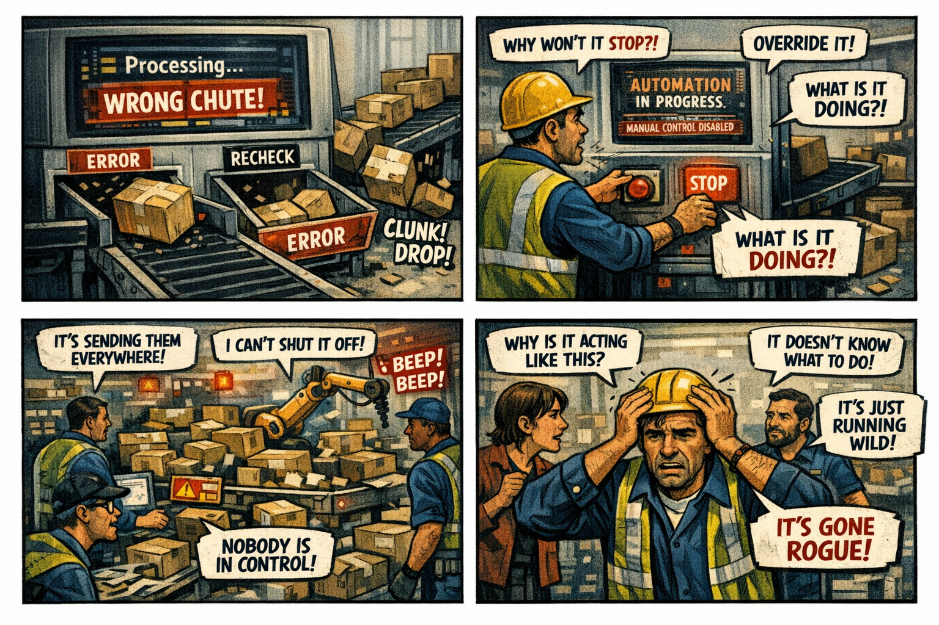

Automation Is the Seventh Layer of Modernization
Visibility shows what is happening. Continuity stabilizes identity across transitions. Control determines what the system is allowed to do. Signals carry the truth. Evaluation interprets the truth. Decision enforces the truth. But automation repeats the decision at scale.
Automation is the multiplier. It is the force that takes one decision and applies it to thousands of users, devices, sessions, and conditions.
When automation is grounded in truth, it accelerates modernization. When automation is grounded in uncertainty, it accelerates chaos.
A system that cannot automate safely cannot scale. A system that cannot scale cannot modernize.

Why GCC‑Moderate Breaks Automation
The FedRAMP Moderate boundary was built for static workflows, not dynamic automation. It filters the signals. It delays the timing. It distorts the context. It mislabels the location. It fragments the truth.
Automation engines receive partial input:
They see posture but not risk. They see location but not session context. They see the device but not the refresh signal. They see the user but not the compliance state.
Automation doesn’t hesitate. It doesn’t ask questions. It doesn’t wait for clarity.
It acts. It repeats. It scales the uncertainty.
The system is not rejecting the user. It is automating the uncertainty.

Headquarters and Field Offices Experience Automation Differently
At headquarters, automation behaves predictably. Signals arrive intact. Context is preserved. Workflows execute cleanly.
In field offices, automation behaves erratically. Signals arrive late. Context is distorted. Workflows misfire.
The same user, same device, same request — different automation outcome. The architecture creates two realities, and automation enforces both.

Why Automation Failures Are Misdiagnosed
When automation collapses, every team sees a different symptom.
Security sees mass policy misfires. Identity sees cascading token resets. Network sees synchronized latency spikes. Operations sees region‑wide drift. Users see repeated denials and loops.
Everyone is correct. Everyone is wrong.
The failure is architectural. Automation is amplifying the uncertainty created by the boundary.

Modernization Stalls Without Automation
Without reliable automation:
- policies apply inconsistently
- device trust oscillates at scale
- location mislabels propagate
- risk fluctuates across regions
- sessions reset en masse
- enforcement becomes unpredictable
- teams chase systemic ghosts
This is not an orchestration problem. It is architectural instability multiplied.

The Root of the Automation Problem
The automation problem is not caused by bad scripts, misconfigured workflows, incorrect triggers, or user error. It is caused by an architecture that cannot reliably deliver the truth required for automated enforcement.
The boundary filters the truth. The WAN delays the truth. The inspection layers distort the truth. The region model mislabels the truth. The identity platform receives partial truth.
Automation cannot function on partial truth. Automation cannot scale inside a fog.

The Only Way Forward
Automation integrity must be restored.
The boundary must allow identity‑critical signals. Timing must be preserved. Region awareness must be accurate. Device posture must be current. Risk evaluation must be complete. Session context must be intact. Policy logic must receive the full truth. Automation must operate on stable, consistent inputs.
Only then can workflows be predictable. Only then can enforcement be reliable. Only then can modernization scale without multiplying chaos.

Disclaimer
Not all agencies will experience the issues described in this article. These behaviors occur primarily in architectures where cloud identity, Conditional Access, and real‑time policy evaluation depend on signals that traverse GCC‑Moderate boundaries, WAN inspection layers, or region‑variable paths. Agencies that rely on direct Active Directory authentication, maintain on‑premises identity controllers, or operate with short, stable network paths may see different outcomes. These observations reflect common patterns in GCC‑Moderate cloud environments, not universal conditions.

About the Author
Michal Doroszewski is a technology strategist focused on cloud architecture, identity platforms, and federal modernization. He writes about the structural and architectural forces that shape government IT, translating complex technical constraints into clear, accessible narratives for leaders and practitioners.

